1) How i can see from command prompt that on which directory you are ?

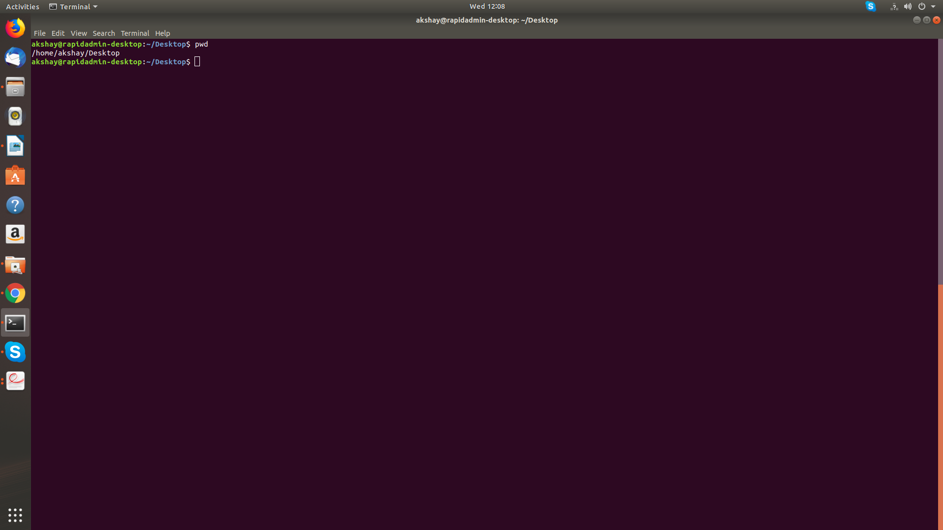

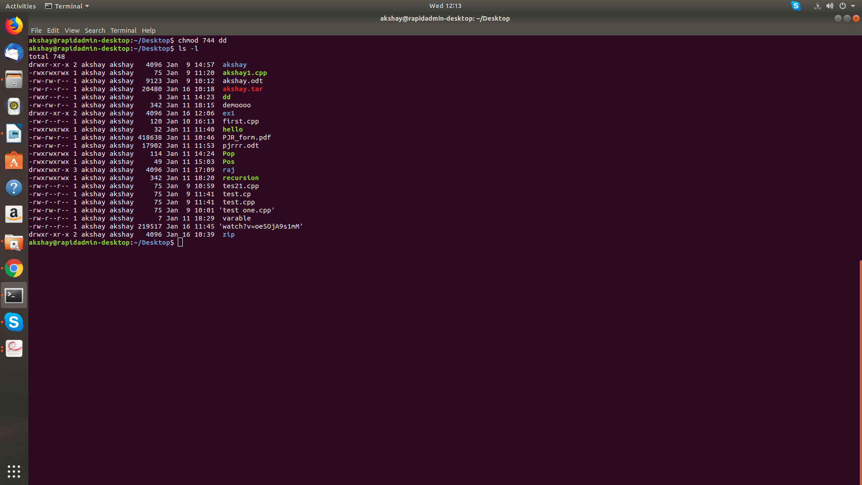
2) How i can change permission of file to read only for that user ?

3)how i can create new user ?

Commmand :-Useradd

4) how i can install mysql in ubuntu ?
Sudo apt-get install mysql-server

5) How i can set insert mode on VI editor ? And how i can save data in file using VI editor ?

Insert mode :- i
for save date :- :w

6) if i want to search from history of command then which short cut i can use ?
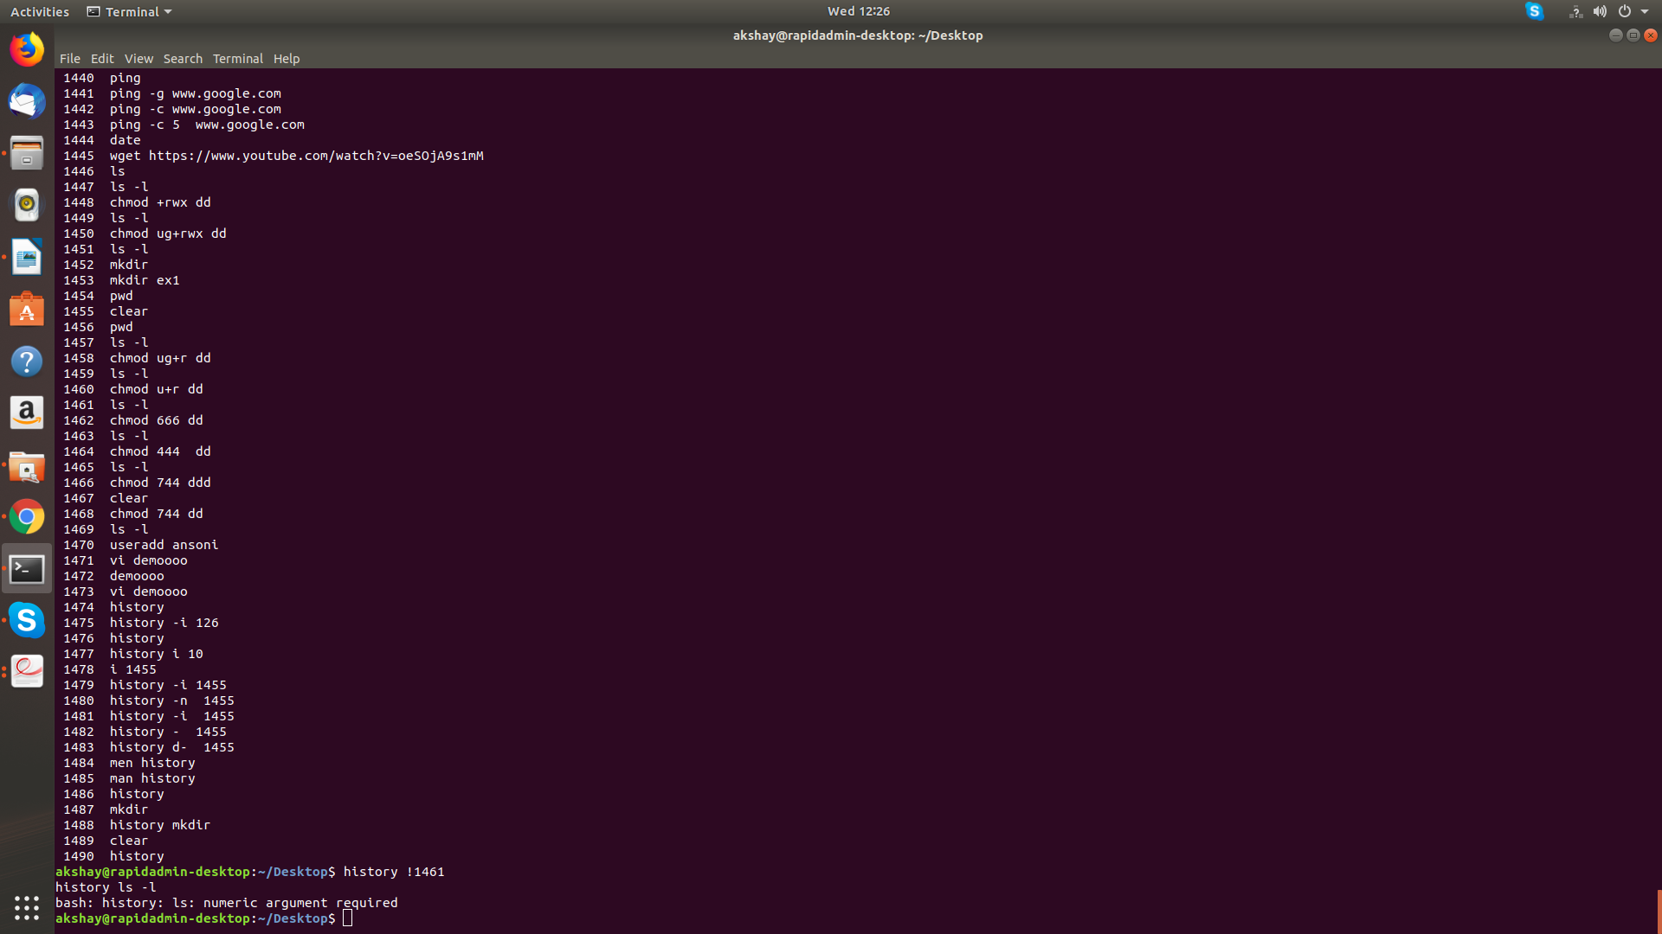

7) Write a command which gives me running mysql process and its pid

command:- Pidof mysql

8)which command helps me to copy file from my local machine to remote machine ? Give one example

scp /home / akshay/ Desktop /demoo akash
9) Write a command that will display all .txt files, including its individual permission.
Ls -l *.txt

10)How can i terminate all process at once ?
Killall -u akshay

11)how i can get first 10 lines of any file ?

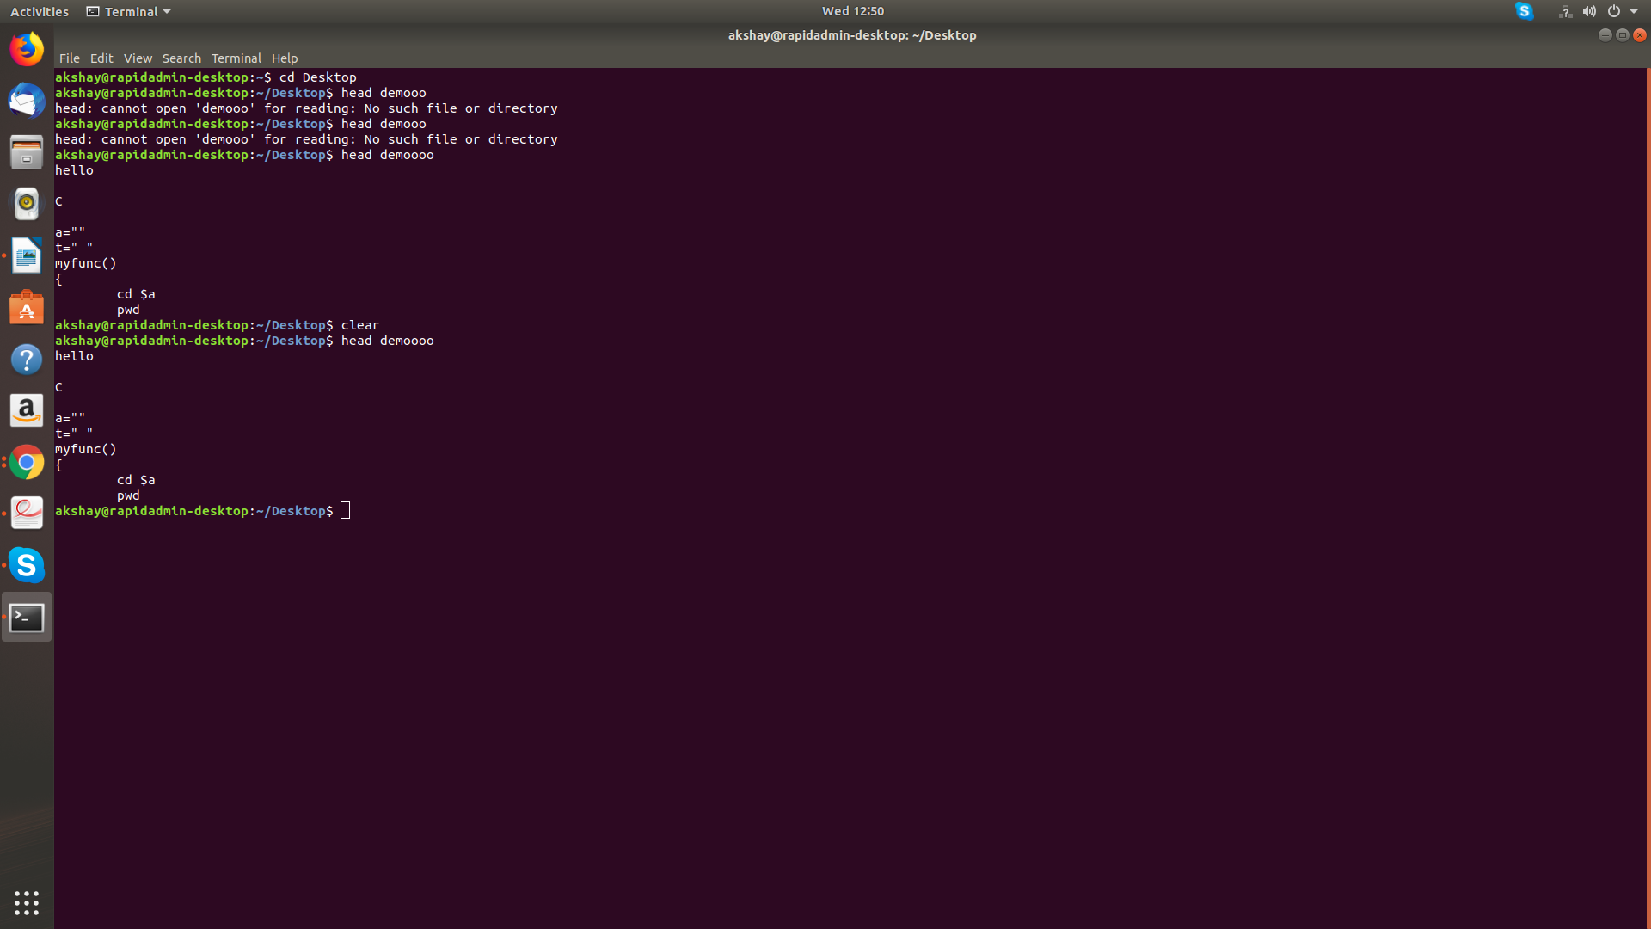
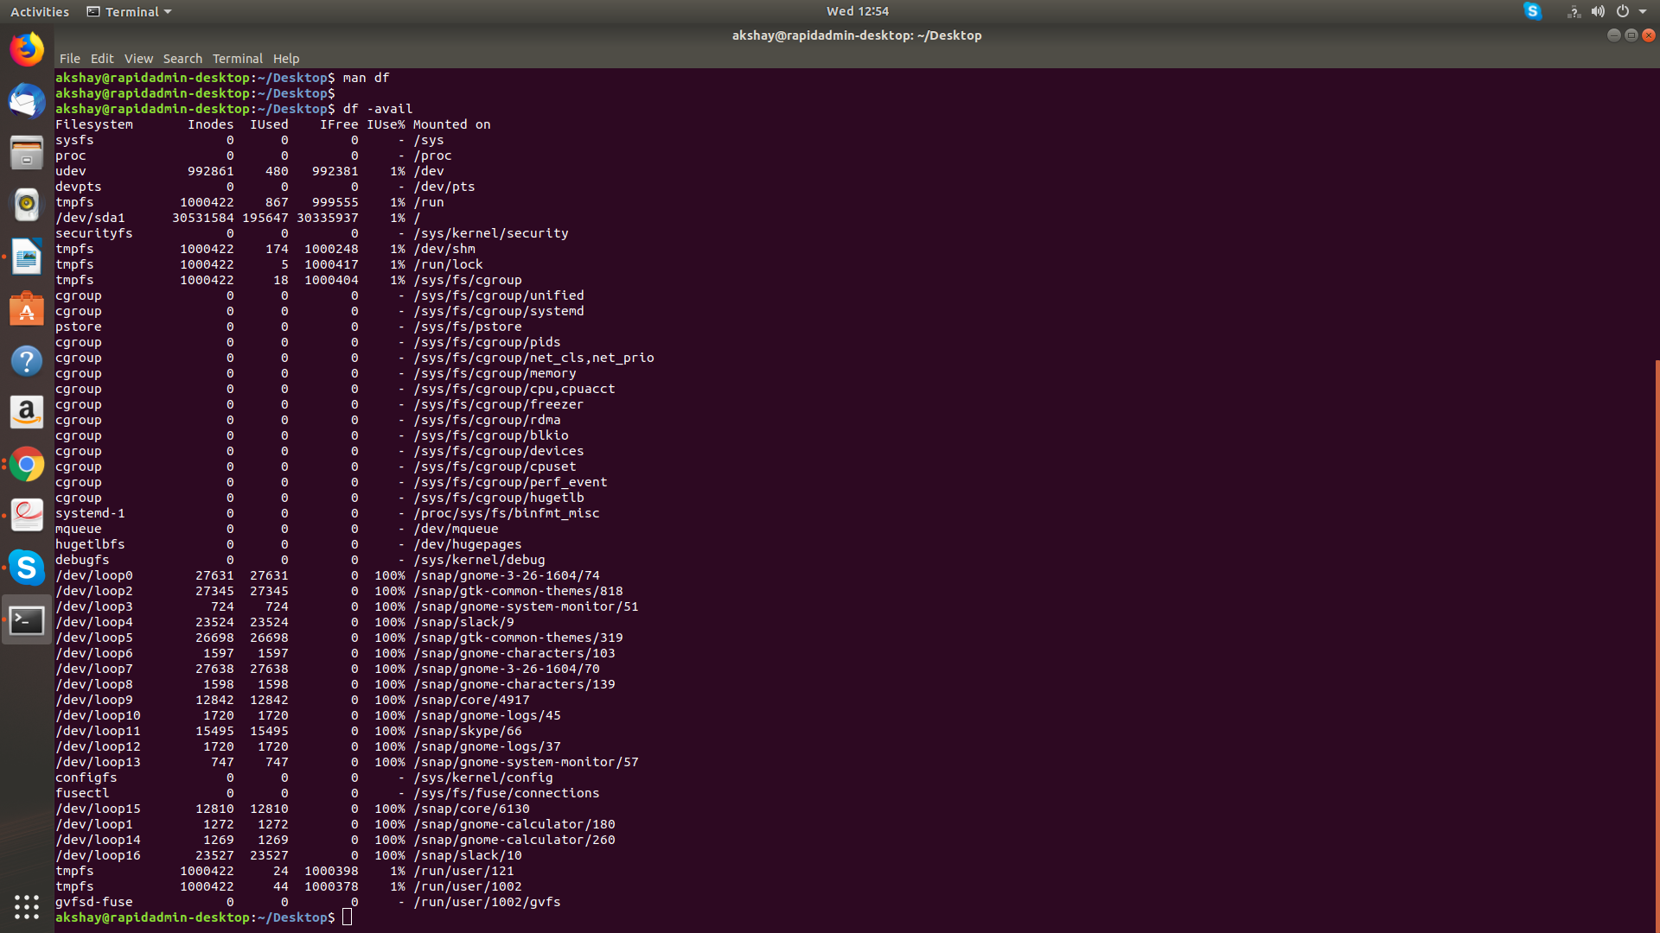
12)how i can know free space on disk ?

13)write command which remove folder from my machine.
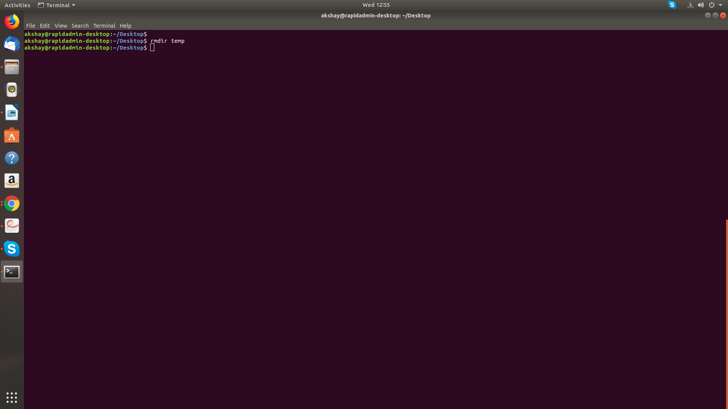

14)Which command helps me to search contents of a file for particular pattern ?

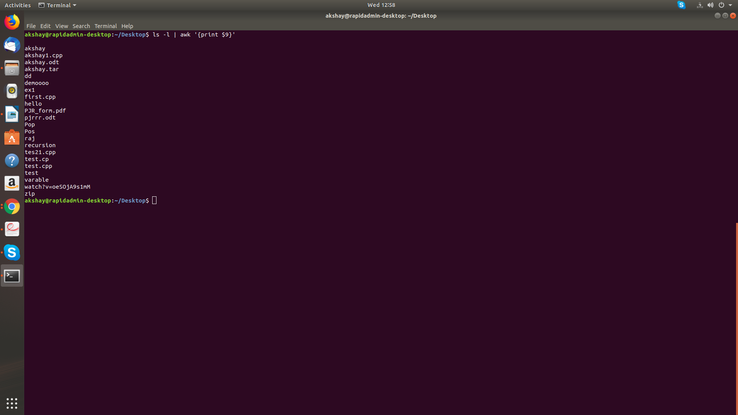

15)Write command to display current date in the form dd/mm/yyyy.
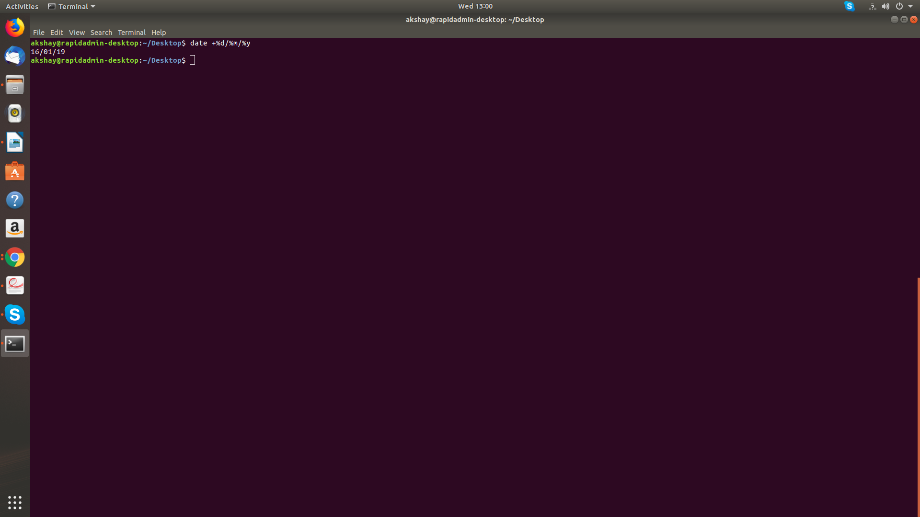
16) how i can remove all lines from file ? (without removing that file)

truncate -s 0 <filename>
17)The permission rwxr—r— represented in octal expression will be ?
c) 744
18)Which command can be use for change user password ?
Passwd
19) how and where i can set test.rapidops.com against localhost ?

20) Create file and set its group as root
groupadd root

